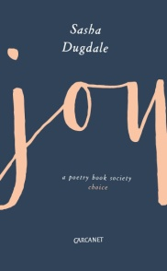
Joy Booking Form
On Thursday 21 June there will be a reading of ‘Joy’ a dramatic monologue in the voice of Catherine, widow of the poet and engraver William Blake. ‘Joy’ is the title poem of Sasha Dugdale’s latest collection and winner of the Forward Prize for Best Single Poem 2016.
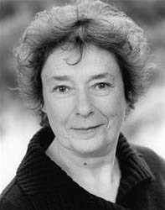
Actress Linda Bassett, well known for her role in Call the Midwife, will read this beautifully crafted poem, described by the Forward judges as ‘an extraordinarily sustained visionary piece of writing'. Sasha Dugdale will discuss her research and answer questions from the audience.
Linda Bassett has appeared at the Royal Court, the National Theatre and Donmar Warehouse. She was nominated for BAFTA Best Actress award for her role in the 1999 ﬁlm East is East. Her television credits include Victoria Wood's Dinnerladies, Lark Rise to Candleford and since 2015 the role of Nurse Phyllis Crane in ​Call the Midwife.
Sasha Dugdale is a poet, translator and playwright. She has published four collections of poetry with Carcanet, Notebook (2003), The Estate (2007), Red House (2011) and Joy (2017). In 2017 she was awarded a Cholmondeley Prize. Between 2012 and 2017 she was editor of Modern Poetry in Translation. She is co-director of Winchester Poetry Festival.
7.30 pm Thursday 21 June 2018
QEII Theatre
Winchester College
Kingsgate Street

Full Price Tickets:..........at £10.00

Under 25s Tickets:.............at £5.00

If you would like your tickets posted to you please add £0.60 or enclose a stamped self-addressed envelope.

TOTAL PAYMENT: £................

Please make cheques payable to ‘Winchester Poetry Festival’

Return booking form to Winchester Poetry Festival, 41 Nuns Road, Winchester, SO23 7EF

Name:..............................................................................

Address:............................................................................Postcode:...........

Telephone No: ................................................................

Email:...............................................................................

Please tick if you would like to be added to our emailing list

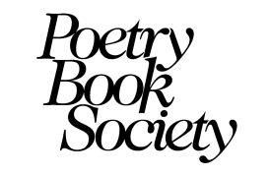
Joy is supported by the Poetry Book Society

